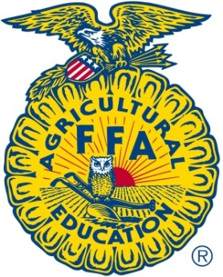
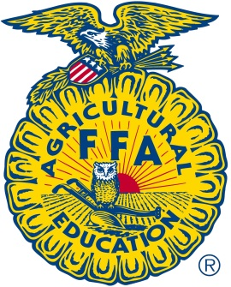
BHS FFA
Spaghetti Supper
& Silent Auction
February 8th
To go plates available starting at 4:30
Dinner starting at 5:00 til 8:00
Tickets: $6

